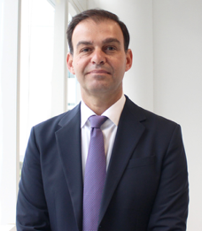
Professor Alex Stojcevski
PhD, D.Sc. (Honoris Causa), FIEAust, MEng, MEd(Leadership), MPBL, BEng.

Professor Alex Stojcevski is an educational leader and executive with experience across three diverse continents, including Australia, Europe, and Asia.

Professor Alex Stojcevski is currently the Pro Vice-Chancellor & President of Curtin Singapore.

Prior to Curtin Singapore, Professor Stojcevski was the Dean of Science, Computing and Engineering Technologies at Swinburne University of Technology, Melbourne Australia. In addition, Professor Stojcevski has held senior leadership positions at RMIT University based in Vietnam, and Deakin University in Australia. Professor Stojcevski also holds a Distinguished Professor position with Sanjay Ghodawat University, India. He is also an invited Fellow of the Institute of Engineers Australia.

Professor Stojcevski holds a Doctor of Philosophy degree in Engineering, Masters by research degree in Artificial Intelligence and Fuzzy Logic, and a Bachelor degree in Engineering. He also holds a Master degree in Educational Leadership and a Master degree in Project Based Learning (PBL) from Aalborg University in Denmark.

Professor Stojcevski is internationally recognised profile in renewable energy, artificial intelligence, and industry problem/project-based learning. Professor Stojcevski is in the world's Stanford/Elsevier's Top 2% Scientist. He has published over 450 articles and has supervised more than 30 PhD student completions.

He has very strong collaboration with a number of industries and Universities worldwide, resulting in income-generating partnerships of over AUD$105m.

